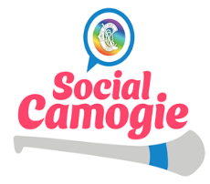
Social Camogie – Club Waiver for Participation
Please returned signed waiver to shauna.fox@camogie.ie prior to your first session, in order to be eligible to participate.
Name of Event | Social Camogie – Start Up Waiver
Club Name
Coordinator Name
Location
Start Date
Signed by Club Coordinator

The Camogie Association strongly and The Participating Club (Mentioned Above) recommends that each participant has in place their own Personal Accident or Private Health Insurance which covers them when participating in Social Camogie.

Please tick here if your club has personal accident insurance in place for Social Camogie Players listed below .

The Participating Club (Mentioned Above) and The Camogie Association accept no responsibility for participation injuries that may occur.

Please tick here if your club has personal accident insurance in place for Social Camogie Players listed below .

All persons who willingly participate in any physical activity including Camogie accept the risk of injury inherent in participation and it is their own personal responsibility to ensure they have cover in place to meet their own needs in the event of an accidental playing injury.

Participants are not covered by the Camogie Personal Accident policy whilst participating in this programme – unless your club has availed of their own personal accident policy for members or you as an individual have this cover. It is advised to discuss the options that are available within your club.

If your club has personal accident insurance cover for participants, please tick here.

If your club has personal accident insurance for players, this waiver will act as a form of registration and formality to take part in Social Camogie.

Please state your insurance provider here (if applicable): _______________________________

Signed: ________________________________________________

Social Camogie Coordinator

Participant Name (PRINT) | Signature | Tick here if you have personal accident insurance/health insurance in place or if your club provides this.
Participant Name (PRINT) | Signature | Tick here if you have personal accident insurance/health insurance in place or if your club provides this.

