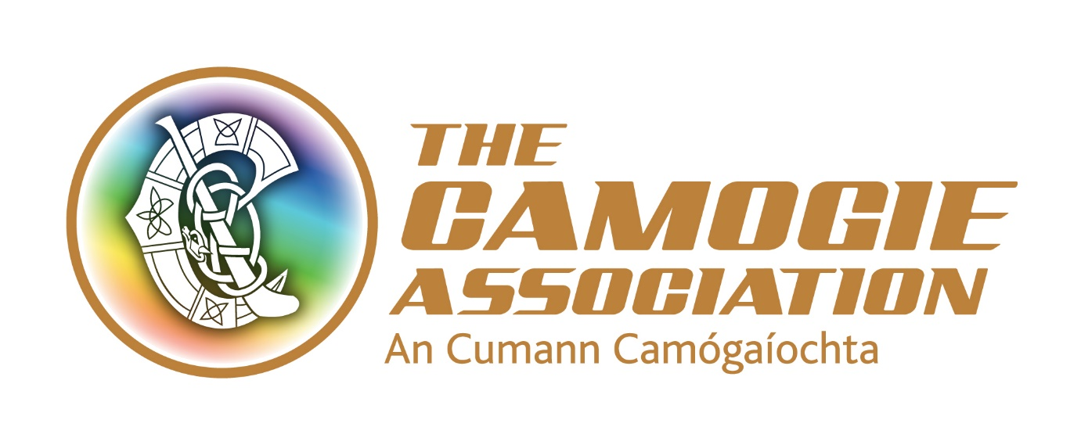

THE CAMOGIE ASSOCIATION
LEVELS OF INVOLVEMENT & ENGAGEMENT
IN THE CAMOGIE ASSOCIATION
BASELINE RESEARCH STUDY
TERMS OF REFERENCE
DRAFT FOR APPROVAL BY ARD CHOMHAIRLE
24 June 2022

1. INTRODUCTION
1.1 The Camogie Association (An Cumann Camógaíochta) is the National Governing Body (NGB) for the game of Camogie on the island of Ireland, and is responsible for the administration and development of the sport.
1.2 In 2019, the Camogie Association commissioned a National Development Plan (strategic plan), which was scheduled to launch in the Spring of 2020. The 4-year National Development Plan is tasked with strategic development of the association, and objectives include: growing membership levels through a structured programme work, involving partners from the education and community sectors, as well as government agencies, local sports partnerships, provincial and county boards, and clubs across the island of Ireland. This covers all aspect of camogie, including active participation, coaching, officiating, and volunteering.
1.3 After a delay caused by the Covid-19 pandemic, the plan was launched virtually in August of that year. An online survey, to measure progress against the aims and objectives of the plan, which had been developed as part of the National Development Plan development planning process aimed to capture, outputs, satisfaction ratings and outcomes from actions, was delivered in the winter of 2020, generating 295 submissions from respondents across Ireland, with a heavy bias towards older, non-playing Camogie participants.
1.4 The National Development Plan Implementation Committee was established early in 2021, to review the implementation of the plan, and develop a suite of performance indicators, milestones, and targets against which progress can be measured. The committee recognises that measurement and evaluation of progress using these KPIs is dependent upon accurate and timely information, and it now seeks to deliver a comprehensive consultation and engagement process which will deliver this data to the Camogie Association.
1.5 The consultation and engagement plan will focus on developing quantitative data to support the Camogie Association’s reporting against the aims and objectives of the NDP, with reference to insight from existing data sources, and informed by conversations with active Camogie members and the coaches, officials, volunteers, and administrators who support their participation. At the mid-point of the plan, it is key to understand the data to ensure delivery of objectives within the lifetime of the plan.
1.6 Opportunities for collation of statistically relevant and comparable data will be significantly enhanced by the development of online resources which are regularly engaged with by the Camogie Association and its members.

2. RESEARCH AIMS & OBJECTIVES
2.1 As part of the Camogie Association’s initiative the main aim of the research is to establish the baseline position with respect to involvement with and engagement in Camogie, and attitudes and perceptions towards Camogie across Ireland. In conducting this research, the contractor will provide The Camogie Association with robust and objective baseline data in relation to the Association, and in particular the National Development Plan objectives, against which agreed performance targets can be set and measured reliably at regular intervals in the future.
2.2 Objective 1: Camogie Association Data Audit
Using the official records from the Camogie Association conduct a programme of secondary analysis to develop an improved understanding of the following groups:
- Active participants;
- Coaches;
- Match Officials;
- Volunteers;
In addition, the contractor will be expected to review any available data relating to availability of facilities for the delivery and development of Camogie, and the financial position of clubs, counties, and provinces, , though it is recognised that this is likely to be more limited in terms of availability and scope. The successful contractor will be expected to be able to identify and access other relevant data and research developed by third parties which may support and inform the consultation and engagement plan.
2.3 Objective 2: Camogie Association Survey
In order to obtain data that are not available from existing records the contractor should conduct an online survey of camogie participants on the island of Ireland, the UK and beyond. This should include, but not limited to, an audit of teams from every age group through to seniors. Beyond playing competitively, The Camogie Association is also interested in other forms of involvement in clubs such as social camogie, social/honorary memberships, coaching, administration, officiating and other forms of volunteering (e.g., Scór, pitch / club maintenance). This strand of work should look beyond the clubs and quantify contributions made by members at local, county, provincial and national levels. The survey should also look beyond sport to identify the contribution of camogie to Irish culture and language as well as the general wellbeing of participants.
The survey instrument developed should be reusable over life of the National Development Plan, and enable effective data mining.
2.4 Objective 3: Qualitative interviews with Camogie participants and volunteers
The results of the quantitative survey will be explored further through deeper, exploratory conversations with a small sample of participants through focus groups and individual engagements. The contract will be expected to identify and recruit interview participants, abiding by principles of good practice in research ethics (to include informed consent, a privacy policy and guaranteed confidentiality for those who engage with the process).
This consultation also forms part of the Camogie Association ongoing commitment and compliance with the Voluntary Code of Governance.

3. RESEARCH METHODOLOGY
3.1 Objective 1: Club Membership Audit
Access will be provided to the Foireann database to collate the official data submitted by Camogie Association clubs as part of the member/ club affiliation process. The contractor will need good database and spreadsheet skills in order to collate and interpret this headline data relating to Camogie. It is anticipated that the contractor will work in partnership with the Camogie Association NDP Implementation Committee and staff from within the Camogie Association to extract maximum value from this source. It is understood that work is currently underway which may deliver further primary research which will inform this study, and contractors should be prepared to incorporate and respond to this output during the contract period. The Camogie Association require that the confidentially of this data is respected and full compliance with all necessary protocols under GDPR. The output should be presented in a variety of forms, easily understood, using tables and charts that can be presented to lay audiences and for circulation where appropriate.
3.2 Objective 2: Camogie Association Survey
The purpose of this objective is to build upon the findings of Objective 1 and to gather information which can only be obtained by direct contact with Camogie members and those who support their participation in the game. The data from Objective 1 will form a test of reasonableness to determine whether or not central membership records accurately reflect the scale and nature of participation in Camogie. The Camogie Association envisage that the (primarily quantitative) survey will be conducted online, although there some provision may be required for those without access to a computer or smartphone. An agreed proforma of the data required from each GAA club will be produced by the contractor and signed off by the NDP Implementation Committee prior to any data collection being conducted. There is an expectation that the survey will achieve a minimum sample of 10,000 responses, though this may be subject to revision.
3.3 Objective 3: Qualitative Interviews with Camogie members and Volunteers
To complete the picture of camogie provision on the island of Ireland, the third objective is to gather qualitative data from Camogie members and volunteers via one-to-one interviews and focus groups. As per the quantitative survey, the Camogie Association is not prescriptive about how the data are gathered (with respect to structured or semi-structured online, telephone or face-to-face interviews). However, an agreed proforma will require the agreement of the NDP Implementation Committee prior to data collection. The Camogie Association expects that the sample size of the survey will be determined by the provider with reference to the funds and time available for interviews. Nevertheless, the final sample should be large enough to permit analysis by geography and demographic group where possible, and that the sample should be broadly representative in terms of age, geography, and roles within the game.

4. REPORTING
4.1 The contractor will be expected to produce a full report and summary, including data extensively and clearly presented in tabular and graphical form as a reliable baseline against the future performance of the NDP can be assessed. Consequently, the Camogie Association will require surveys to be signed off as true and accurate representations of the facts attained to each respondent and the survey template to be presented in such a way as to be repeated after year 3 and 4 of the plan.
4.2 The contractor will be expected to present the report’s findings to the Camogie Association Ard Chomhairle (Board) and staff (around 100 people in total) at a date to be determined after the completion of the study.
4.3 The Camogie Association expect the contractor to work collaboratively with the NDP Implementation Committee and Management team and to provide regular updates as an integral part of good customer service.

5. BUDGET
5.1 The proposed budget should include all costs related to the research project (including travel and any other relevant expenses).
5.2 The project methodology and cost proposal should be itemised, to provide clarity on deliverables and their costs, at each phase of the project.

6. TIMESCALE
6.1 A proposed timetable is included below, though detailed timings will be agreed on award of the contract.
6.2 The start date for full fieldwork is scheduled to commence no later than 1 Sept 2022.
Item | Date
Invitation to tender | w/c 21st June, 2022
Deadline for proposal and quote | 4th July, 2022
Assessment of proposal | 7th July, 2022
Project initiation meeting | w/c 18th July,2022
Sign off Research Instruments | w/c 8th August, 2022
Fieldwork commenced | w/c 29th August,2022
Fieldwork completed | w/c 12th Sept 2022
Analysis and Draft report (s) | w/c 3rd October 2022
Final report (s) & presentation of findings | w/c 17th Oct 2022

7. PERFORMANCE AND QUALITY
7.1 In undertaking the work, contractors shall use their professional skills and experience to advise or propose matters relevant to the project, but which may not be necessarily listed, described, implied or evident from the contract documentation so provided.

8. PROJECT MANAGEMENT
8.1 A project management structure will be implemented within The Camogie Association. The contractor may also be required to report to the NDP Implementation Committee at regular intervals.
8.2 Please state clearly what human resources will be employed on all aspects of the research – including field staff. This should include clearly defined project roles for all key named individuals. Please also include a contact name for day-to-day communication with The Camogie Association and a succession plan for in the event of this project manager moving on.

9. RISK ASSESSMENT
9.1 Please state what you see as the key risks for this project – with contingency plans as applicable.

10. PROJECT PROPOSAL
10.1 The project proposal should be concise (maximum of 4 pages of A4, excluding appendices) and presented in report format to include the following:
- Outline of method and approach to the research;
- Details of key staff to be allocated along with dedicated time commitment to the project together with a resume of their experience and professional qualifications.
- The proposed budget based on daily inputs and all other expenses.
- Examples of recent relevant comparative work
- References – at least 3
Proposals must also be accompanied by:-
- Proof of Insurance
- Tax Clearance & Compliance Confirmation
10.2 All documentation should be sent to:
Sinead McNulty at sinead.mcnulty@camogie.ie by 5pm on 4th July, 2022.
10.3 Please type in the subject field of your email “The Camogie Association Research Project”.

11. CONTACT DETAILS
11.1 Your point of contact within The Camogie Association will be:
Sinead McNulty
Chief Executive Officer
The Camogie Association
2nd Floor, Westward House,
Russell Street,
Dublin 1
D01 F300
Tel: +353 (0)1 865 8651
E-mail: sinead.mcnulty@camogie.ie
Please Note - The Camogie Association reserve the right not to proceed with this project, at the discretion of Ard Chomhairle and Management.

