School Name:​ Loreto Secondary School Kilkenny.

Entrants:​ ​Eabha Doherty, Emma Walsh, Hannah Kehoe.

Title: ​The Dropout Age and the Reasons Why Girls Quit Camogie.

Date submitted: ​10.12.2020

We have noticed a recurring trend in the Camogie Association, that teenage girls tend to drop out of camogie from unnecessarily young ages. This really inspired us to investigate the reason why they do so and when, so we can understand the stages in life when it happens so we know why they give it up and how we could keep them in the sport. As we are attending school in the hurling country of Ireland, Loreto Kilkenny, there is a much higher rate played here than elsewhere, but even still there is a huge amount of dropout numbers and we see it as a massive problem for our future camogie teams.

Camogie is the most played sport among girls in Ireland. Even though it is hugely popular in Ireland, massive numbers of girls do not play camogie or in fact any sport at all. This is very worrying for society in general because sport is so important for girl's health and wellbeing. Way more boys play hurling and other sports than girls and it's been this way forever. Hurling gets way more attention than camogie. Take All-Ireland day for hurling: The whole stadium is full, huge queues for tickets, and match updates all over the media. However, during the Camogie All Ireland spectators on fill one stand. Not only does this knock the girl’s confidence to run out onto the pitch and only have a stand of supporters compared to the men who would have a roaring stadium full of supporters. This needs to change if we want more girls playing Camogie at a high level, as at the moment they don't get half the opportunities the men do. People tend to watch hurling because it is more physical and therefore more entertaining but yet it is a foul for girls to get physical. The difference between them are:
- In camogie, a player can hand-pass a score which is forbidden in hurling. Players are also permitted to drop their hurl to handpass a score in camogie but not in hurling.
- Camogie matches last 60 minutes, compared to 70 in senior hurling.
- The sliotar used is slightly smaller in camogie (size 4 sliotar), compared to the slightly heavier size 5 ball in hurling
- Shouldering is not permitted in camogie.
- The ’65′ awarded when a defender last touches a ball going over the goal line is taken from the ’45′, in camogie, which is closer to the goal than hurling
- Unlike in hurling, where certain rules apply to goalkeepers, they must be the ones to stand in goal for penalties there are no rules differentiating camogie goalkeepers from outfield players. This is why they wear the same colours as outfield players
- Puckouts are taken from the 13-metre line and not the end line.
If girls and boys are all equal, why do girls and boys have to have different rules in sports? It's a very backwards way of thinking and rule changing should be another step towards equal sporting opportunities between boys and girls.
We have distributed a survey to every year in our school, here are the results:
58% do not play camogie and 42% do currently play camogie. The most shocking discovery was that over 83% of students that filled out the survey had previously played camogie. Over 80 students offered a reason why they quit camogie, some being: loss of interest, injury, teammate exclusion, weaker players being left on the bench.
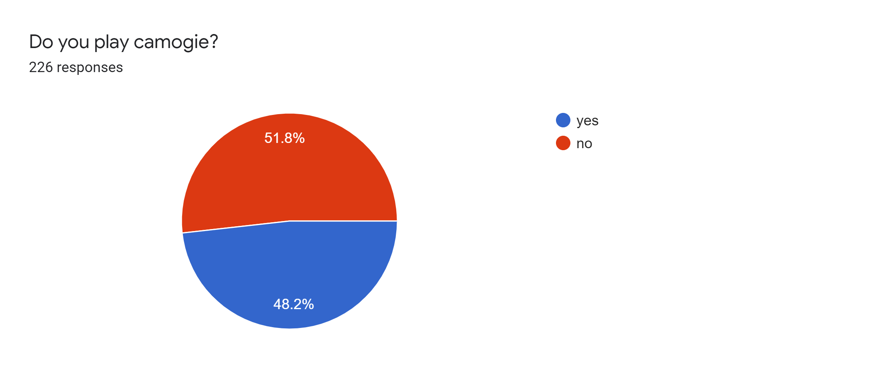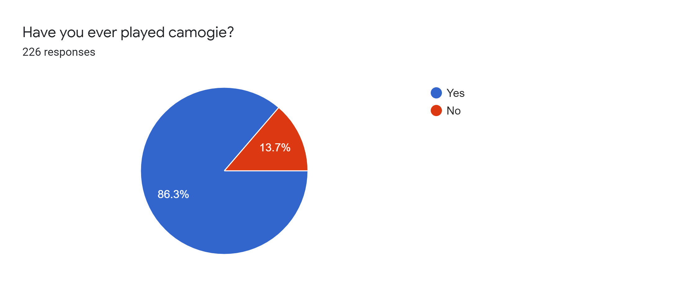
The age groups of when people quit varied. The most common age, at approximately 37%, was age 10, 11 and 12. We believe that numbers dropped so much at this age as this is when camogie begins to get extremely competitive and too much pressure is put on young girls.

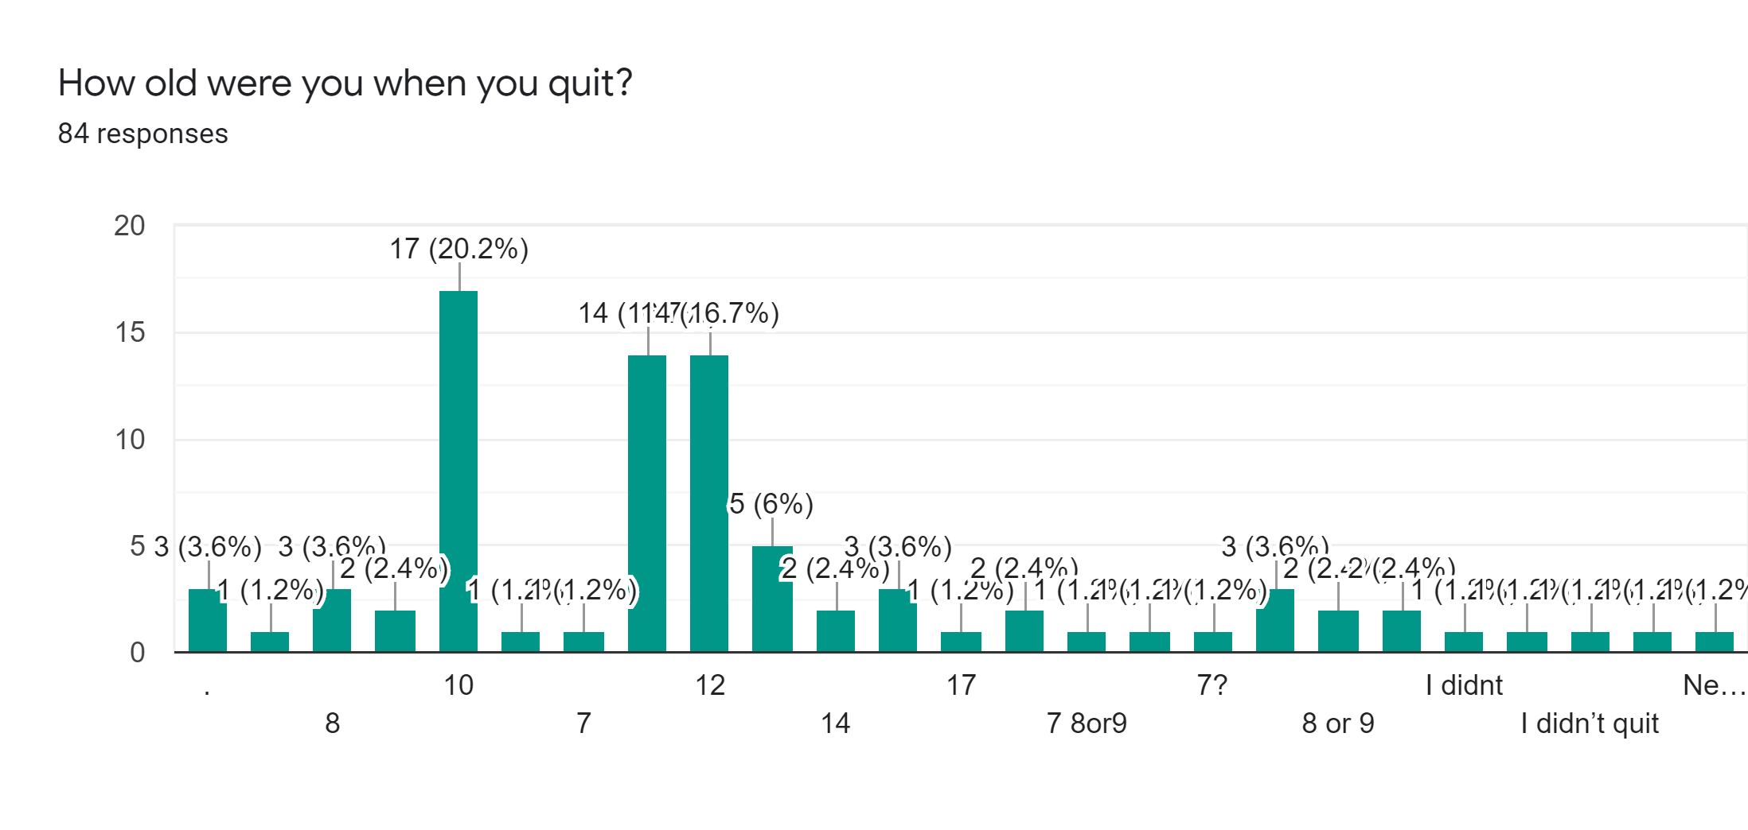

To conclude our survey, we asked how camogie can be improved to keep numbers up. Some requests were quite alarming suggesting that coaches can sometimes be the problem. We think some coaches are far too focused on the competitive aspect and while this is important it is not the main focus of the camogie association. Camogie’s main values are innovation, integrity, Leadership, voluntarism, fun, excellence and Inclusiveness. From our survey this is obvious that students believe that some coaches are not up to standard in various ways and do not appreciate the values of the camogie association.

For some people who have dropped out, they simply didn’t like it and we can completely understand this.

Most students admit that they did not have the time for camogie. Time commitments are also quite out of our hands. Although, camogie should not take up a girl’s full weekend etc., we think that camogie should be promoted more in secondary schools as some camogie clubs tend not to be as inclusive which can cause future problems.

Less pressure and easier training sessions were also highly suggested by students. We understand that huge pressure is put on players of different levels and abilities. For example, the star midfielder will be expected to carry the team all the way to the county final. This kind of stereotyping cannot be tolerated as this is what causes young girls to drop out. We also believe that training needs to be an equal combination of cardio and strengthening that has been designed to include everyone at different levels of fitness.

A lot of students felt that ‘friendlier teammates’ would encourage them to take camogie up again. We think that there can be huge divides in some camogie teams and/or clubs. Girls are not encouraged enough by their coaches and managers to interact with one another outside of their individual friend groups. We think the best way to tackle this issue would be to start team bonding activities from a young age and hopefully this will encourage girls to interact with teammates and therefore keep our camogie numbers on the rise.
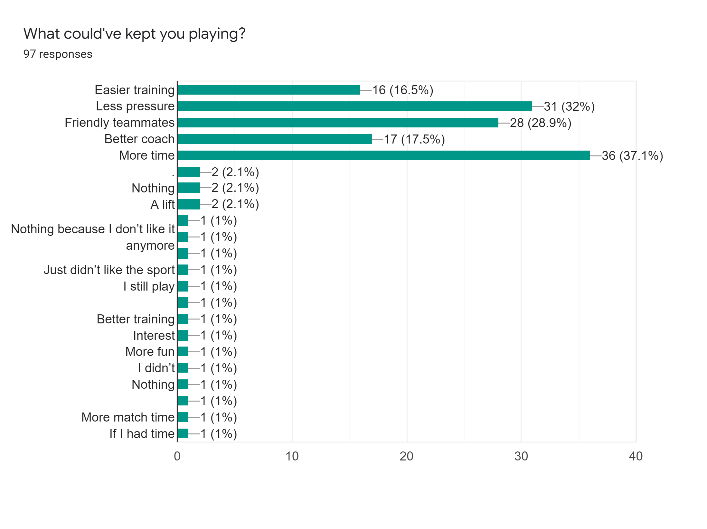

In conclusion we have learned so much about Camogie. Our Survey has taught us that it is not acceptable the number of girls that drop out of camogie and their reasons for doing so. This is something we must change in the camogie society now. We also saw other problems in camogie and things we needed to change like coaches being too focused on the competition and not the core values of the camogie association. We feel like people need to be reminded why they started playing camogie in the first place because it was a fun activity that they enjoyed doing and the enjoyment needs to be brought back into the older age teams in the camogie society. Overall, we will work on these changes to spread more positivity to other girls about camogie and encourage them to get involved.

