Cover page

School name: Loreto Secondary School kilkenny

Entrants: Tara O'Keeffe, Ella Cusack, Leslie Hughes.

Title: Examining the difference between 2nd and 4th year students with Caomige Retention

Date Submitted: Wednesday December 2nd

Introduction

For our camogie retention project, my group and I have decided to examine the difference between second and fourth year students who decide to quit camogie. We chose this title as we found in our year (4th year) that many people decided to stop camogie in 2nd/3rd year. We wanted to interview 2nd years to see what could prevent them from stopping the sport or what could get them involved again.

To do this we plan on carrying out an array of research projects such as surveys,interviews and desk research.

Our aim of this project is to try and keep young girls particularly in secondary school to keep playing sports like camogie, football, basketball or whatever they may be interested in. We want to encourage them to keep fit and healthy even if they decide the sport they were playing is not for them anymore.

Methods used to put ideas into practice

There are many methods of putting ideas into practice. We have chosen 3 methods that we think would be most effective. The three methods we have chosen are sending surveys, doing interviews and doing some desk research.

Methods we will use to put our ideas into practice are by sending out a survey to all of the 2nd years and 4th years. By doing this we hope to find out why people commonly give up camogie and what it would take for them to start up again.

Another method of putting our ideas into practice is by conducting interviews with some 4th year students ( some who play camogie and some who have never played camogie ) We would like to find out in more depth why people give up camogie in teen years and why they keep it on in teen years.

We also will be doing some desk research to see what year teenage girls are most likely to drop out of caomgie and what would have made them stay.

We think that these methods will be most effective as we can get in-depth answers from conducting interviews and also find out the number of people who give up and keep on caomgie in teen years Results - What you would hope to achieve with your idea

We hope to achieve many things with our ideas. We hope to get more people back into caomgie by figuring out why people drop and what it would take for them to come back.

We have done this by sending surveys to 2nd and 4th years - results below:
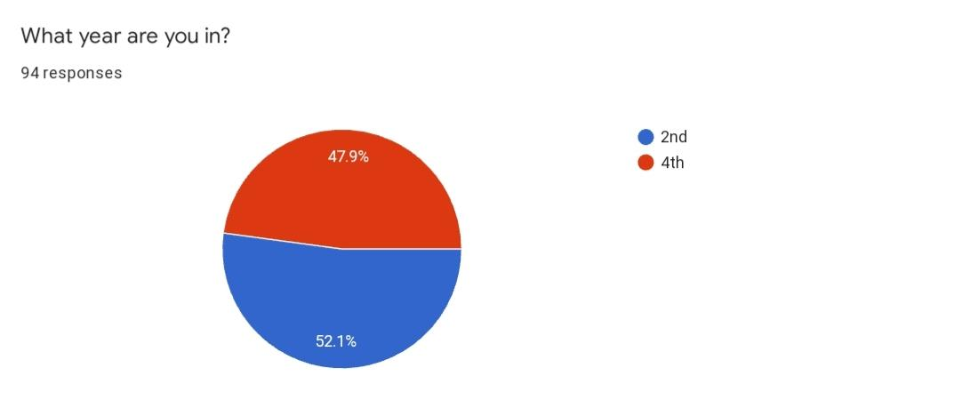
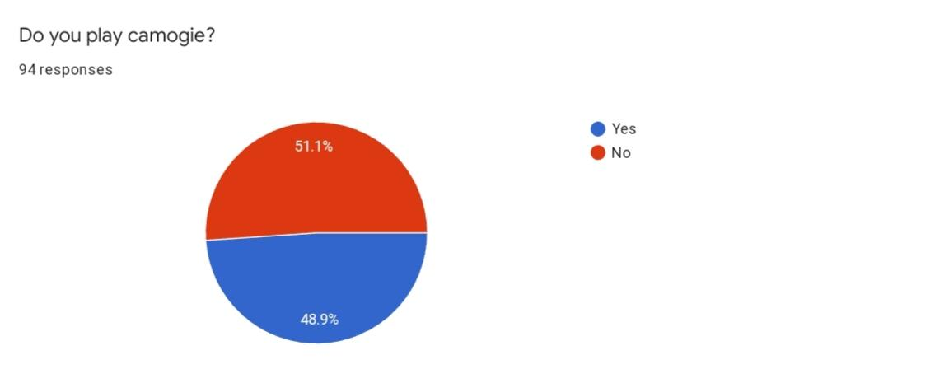
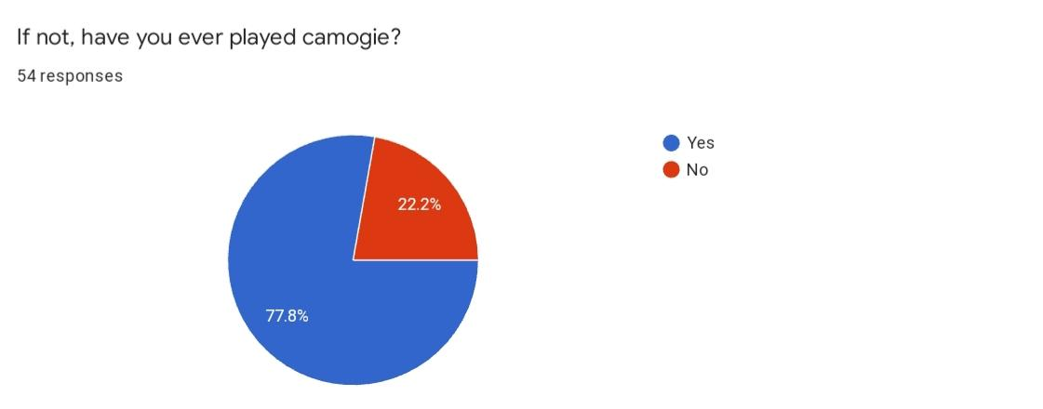
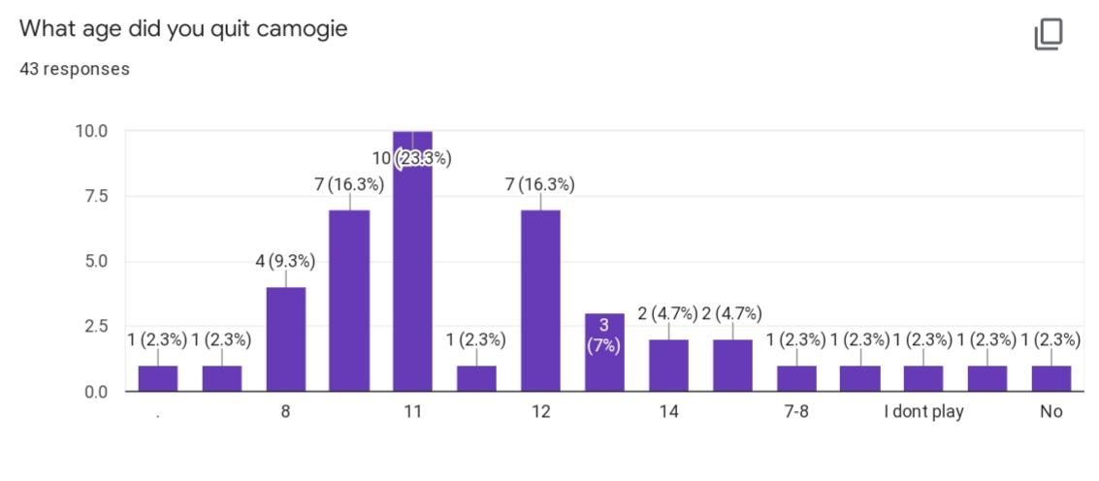
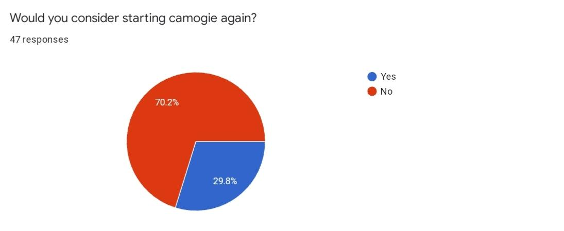

We have also done this by conducting interviews to one4th years who play caomgie and one 4th years who don't- results below.

Caomgie interview 1
Caomgie interview 2
Caomige interview 2 part 2

We also did some desk research and found out that the reason most people drop out in 3rd year is because they find they have to with the Junior cert. This is not the right attitude to have as you need a break from the work to clear your mind and get some exercise and fresh air.

