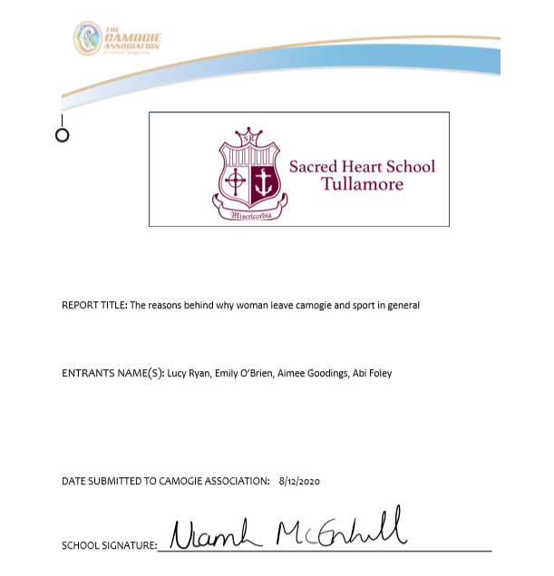

The older we get, the less girls we see playing camogie and other sports. Why is it when we get into our teenage years and sometimes even earlier, we stop playing sports? Why don’t we continue sports and why is it such a struggle to make underage teams unlike most lads who will continue playing until they’re seniors. Why do the men’s teams get more benefits than the women’s teams, even though the women’s teams are just as successful, if not more. There are many reasons why people leave camogie, such as injuries, money, competitiveness and many more. We are going to talk about the reasons why girls leave sports and give you an insight into why we think changes should be made.

Loads of boys and girls start sport at a young age. It is very important to make it fun at first, and then let the competitive side come to it after a while. There is a fine line between fun and competitiveness. People play sports for all different reasons and the different between these two things is the relationships on a team, between friends, coaches and parents is why girls and boys leave sport. If a girl is playing a sport because she wants to do it for fun and to make new friends, but she is constantly getting shouted at by her competitive teammates or coaches, she is going to quit because she doesn’t like this environment. It is okay to have fun and be competitive because that is what sports is about but if people in the sporting community are rude, not supportive, and not encouraging to others, girls are going to stop playing sports.
Another reason why so many girls quit camogie and other sports is because of their parents, coaches and/or teammates. The older we get the more competitive sports competitions get but sometimes some people play the sport for fun, for a social aspect and to just do some exercise. It is commonly seen in both boys and girls matches, almost every team has at least one parent that screams at their child and don’t get me wrong, they only want what’s best for their child but screaming at them isn’t going to get your message through to them, maybe all the kid wants is to have a bit of fun and not take the sport so seriously, but instead their parents are trying to live out their sporting dreams through their child, which isn’t fair to the kid. As well as parents, it can be quite hurtful when playing the likes of camogie, that when you’re a player who never misses training or matches, is always on time and puts in so much effort, to lose interest in the sport because your coach has favourites and always chooses the girl who hasn’t been to training in months and shows up on match day, get a starting position before you because the skill and everything else needed comes easy to her unlike you. Another reason is because when you play a sport like camogie, you are part of a team and inevitably if you don’t get along with some of the girls on the team, it can make training and matches a very awkward time for not only you but also your team mates, especially when there is a clear divide throughout the team.

When playing camogie there is a lot of different priorities that can persuade your choice. The main ones are family, school, training time and social life. These could persuade you to leave camogie or stay. Your family have a big influence on you, they could be influencing you to play like other people in their family, this would make you want to play. Unlike school, depending what year you are in school takes up a lot of your time, between homework, study, sports in school and school in general. This is a very big factor when looking if you want to keep playing. Most people are really busy so trying to find time to go to trainings and matches might be difficult. And lastly Social Life, most teenagers want to be with their friends and want to go into town, this might make them not want to go to training or go to matches.

Money, money, money, it's all about the money. Why aren't we getting paid? It's unfair and is unequal. There is too much of a financial difference between men and woman's sport. 2.3 million euro is the difference of pay. Sound fair? Absolutely not. Men get 3 million euro to buy their meals, their gear, equipment, travel expenses, physio, medical supplies and many more, while women get 700,000 to spend on just facilities. This is a huge problem and in very recent years, equality is a main problem that is being fixed but this is an obvious problem and changes need to be made. Woman don’t receive the same privileges as men, for example a physio. This can end and ruin somebody's career and is why woman stop playing sports. There is a fear of being injured and not having the sources they should be guaranteed. This is unfair as it is an essential to sports as injuries can happen like that. We spoke to a sports teacher in our school and she gave us a quick interview and what she told us was shocking. She spent 11,000 euro over her years of playing county. She's only 25 years old and spent this on sport, but on other hand, men get nearly everything handed to them.

To conclude this essay, we have highlighted a few of the key problems invoveld in womans sport. This is only the start of the many problems in womans sport. There are obvious many more topics that we have covered that also have a huge impact on womans sport. We would like to see the introductions of silent sidelines from FAI soccer assosiation to Camogie and other sports. This would make a differerce because parents and coaches would not be allowed to scream and shout at the children and children would feel less pressured to play the sport that they enjoy. And yes, it is okay to encourge your child or player but not to verably abuse them and say things in an aggressive way. The simplest thing such as silent sidelines will make a big difference in woman playing sport. We also have more questions but we don’t know the answer to such as, Why does our generation still expiernce sexisum after all these years? And Why does society think this is okay ?

We hope you see where we are coming from and ye can take action to better camogie and other sports in the future for players, parents, coaches and the camogie community.

