Camogie Association Development Forum – Resources
Retaining Girls in Sport – Athletics Ireland and Rowing Ireland
Retaining Girls in Sport Webinar
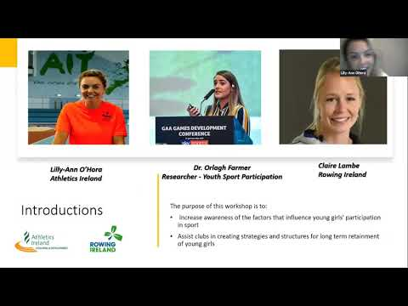

https://www.womeninsport.org/research-and-advice/our-publications/
Selection of reading and listening material on various topics influencing women in sport

Sport Ireland – Giving Young People a Voice
Workshop designed by the Sport Ireland Ethics department available for delivery by Camogie Association tutors
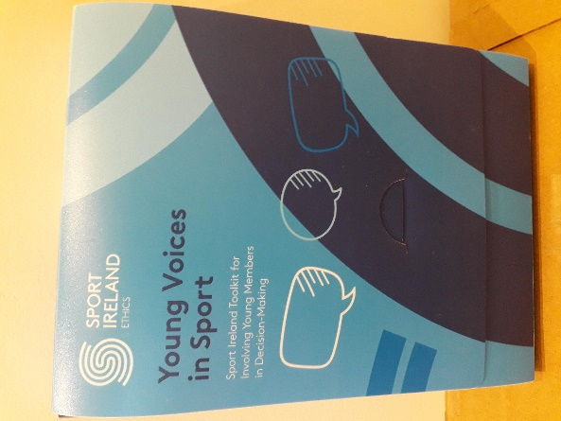

Teenage Retention Example
Cuala teenager showing how to keep girls playing Gaelic Games

Camogie Association Ready Steady Go – Retention Webinar Pt 1
‘Ready Steady Go’ - Episode #6 Part 1
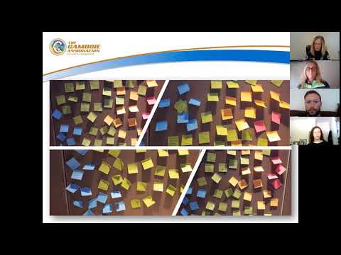
Camogie Association Ready Steady Go – Retention Webinar Pt 2
‘Ready Steady Go’ - Episode #6 Part 2
