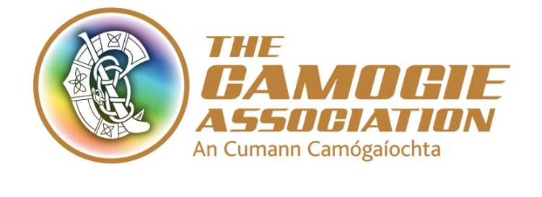

National Development Plan Implementation Sub-Committee - Expressions of Interest Sought
The Camogie Association are seeking expressions of interest for a Chairperson and members of their National Development Plan Sub-Committee, which will run from December 2020 to April 2024. The NDP Implementation Committee is a voluntary sub-committee of the Camogie Association’s Ard Chomhairle – the Governing Body of the Association. The committee will be responsible for evaluating progress on the National Development Plan, during its lifetime, from August 2020 to April 2024.

Context
The Camogie Association, is the national Governing Body for Camogie, responsible for promoting and developing the game, and is an independent voluntary organisation founded in 1904.
Camogie is the most popular female team sport in Ireland with 576 registered Camogie clubs, and through the work of a vast volunteer network, provides a range of training and competition outlets for players of all ages. Camogie has been recognised as making a significant contribution to Irish Sport, as part of the family of Gaelic games with over 2% of the population volunteering in hurling and camogie (Source Irish Sports Monitor), and more than 100,000 people playing the game.
Camogie operates at a Club, County, Provincial and International level with teams of all ages participating in the sport. The Camogie Association works closely with colleagues in the Gaelic Athletic Association (GAA), at all levels. In 2018 Camogie and Hurling were included on the UNESCO Representative List of the Intangible Cultural Heritage of Humanity.

National Development Plan 2020-2023
The National Development Plan 2020-2023 – Reach you Goals, Exceeding your Expectations was formally launched in August 2020 and will run until its replacement is approved at Annual Congress 2024.
The new National Development Plan builds on the progress of previous plans and is based on a thorough consultation process which engaged with over 800 individuals representing all 32 Counties and more than 280 Clubs, as well as funders, sponsors, partners and other stakeholders between November 2019 and February 2020.
Our Vision - Camogie is at the heart of our communities, a game that inspires, an Association for all.
Our Purpose - To develop and promote Camogie at all levels to inspire current and future generations and preserve the heritage of our game.
Our Values - As we work to achieve our vision, everything we do over the next four years will align to the following set of core values:
- Aspiration - Our passion and pride for Camogie, its tradition and its heritage guide our aspirations and the development of the game
- Teamwork - We work in partnership to enhance all aspects of the game at all levels
- Leadership - We lead with integrity and transparency, we have the courage to make strong decisions for the good of the game, to be innovative and provide inspiration both on and off the pitch
- Volunteer - The foundations of the game are Clubs and volunteers; we value and recognise their role and contribution. This underpins our approach and delivery
- Community - Camogie is an inclusive game, accessible
The key messages of the new National Development Plan are ‘Passion, People, Pride and Place’ which represent the foundation blocks of the Association.
The plan sets out 12 key goals across four strategic areas - The Game, Volunteers, Identity and Leadership. These key goals will drive the work plans of the Association at both a staff and volunteer level in the coming years to undertake specific key actions within each goal (set out below).
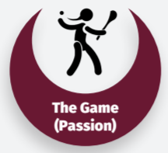 | Goal 1 – To provide lifelong participation within Camogie
 | Goal 2 – To increase the standard of Camogie at Club and County levels
 | Goal 3 – To embrace the fixtures challenge to ensure adequate games programme for all
 | Goal 4 – To promote the health, well-being and welfare of all Camogie participants
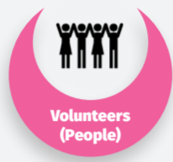 | Goal 5 – To increase the availability of skilled and qualified coaches and referees, and provide a supportive environment for volunteers
 | Goal 6 – To ensure that volunteers and Clubs are valued and have the skills and support to effectively and efficiently administer our game
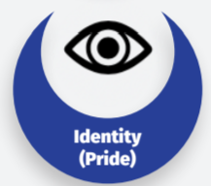 | Goal 7 – To revitalise the Camogie brand and identity
 | Goal 8 – To develop commercially to power and drive our core business
 | Goal 9 – To inspire more people to watch and engage with Camogie, locally, nationally and internationally
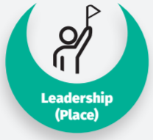 | Goal 10 – To work collaboratively with the GAA and LGFA as part of the Gaelic Games family
 | Goal 11 – To ensure appropriate playing facilities for Camogie
 | Goal 12 – To provide an innovative, dynamic and sustainable Association that demonstrates best practice in governance and partnerships

Informing the annual planning process, as well as the development of the subsequent plan, will be an annual survey, which monitors the outcomes under each of the action areas. Findings from the first survey will be available in December 2020. This measurement process, designed alongside the strategic planning process, looks at outcomes, as well as outputs, and seeks to provide data to enable informed decision making by the Association’s leadership (Ard Chomhairle and Management Team).

NDP Implementation Sub Committee
The National Development Plan Implementation Sub-Committee are an essential element of the effective implementation and delivery of the NDP. Members will be part of an exciting phase of development for the Camogie Association, and will join a dynamic and progressive team of staff and volunteers.
Members will be appointed by Ard Chomhairle following receipt of expressions of interest. Membership will be made up of individuals with expertise and interest in the key areas of the plan, as well as members of the wider Camogie Community and Staff representatives. Members will be part of an exciting phase of development for the Camogie Association. The proposed make-up of the Committee is set out below:

Implementation Team Members | Roles & Skills
Implementation Director/Leader | Responsible for co-ordinating the planning and implementation of Evaluation activities. This includes supervising the evaluation/implementation team. They must have sound knowledge and experience in evaluation, including data analysis and interpretation, and writing and editing of reports.  The ideal candidate will be an External and Independent person, with business management experience.
Specialist(s) in the fields related to the plan | Has knowledge of the planning and development of the strategic plan and excellent understanding of the goals of the plan. Provides technical support and helps develop sound recommendations/findings. The key areas within the plan are: - The Game - Passion  - Volunteers - People  - Identity - Place  - Leadership - Pride
Staff Member | Responsible for implementing the programme, but because they are critical stakeholders in the process, they should be included in the evaluation planning, analysis, and interpretation processes.
Provincial Delegate | This plan, from the start focused on listening to, and engaging with the members of the Camogie community. This implementation plan should be inclusive and give ownership to all of our members. As such a suitable representative from a Provincial level is sought
County Delegate | This plan, from the start focused on listening to and engaging with the members of the Camogie community. This implementation plan should be inclusive and give ownership to all of our members. As such, a suitable representative from a County level be included.
Club Delegate | This plan, from the start focused on listening to and engaging with the members of the Camogie community. This implementation plan should be inclusive and give ownership to all of our members. As such, a suitable representative from Club level be included.

Expectations
- The committee will be in place from December 2020 to April 2024.
- This committee will meet c. 4 times per year, and will feed back to Ard Chomhairle, and prepare a report each year for Annual Congress (April). Meetings may take place in person or online as necessary, and COVID-19 Restrictions permit.
- This is a voluntary role, travel expenses will be provided.
- The Annual National Development Plan Survey will be carried out annually by the staff team, with data returned to the committee for review and analysis.
- The primary means of communication will be by e-mail.
For further information, please contact Sinéad McNulty, Ard Stiúrthóir sinead.mcnulty@camogie.ie and see our website at www.camogie.ie.
- The NDP is available at https://camogie.ie/wp-content/uploads/2020/08/Camogie-Association-National-Development-Plan-2020-23.pdf

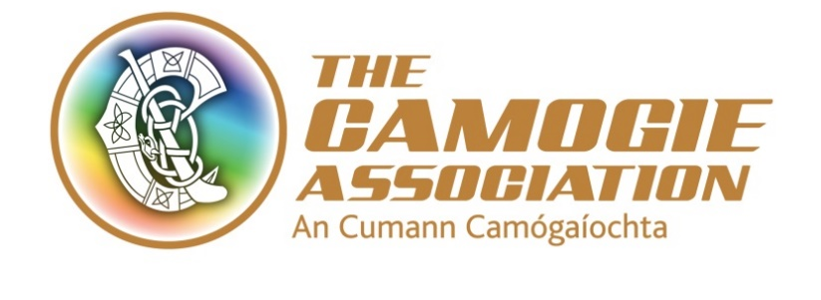

Camogie Association National Development Plan Implementation Sub-Committee

Expression of Interest Form
Submission Closing date: 12 noon, Monday November 23rd 2020
Name:
Address:
Phone Number:
E-mail:
Camogie Club (if applicable):
Role being applied for:
Relevant Skills & Experience:

Submissions should be e-mailed to sinead.mcnulty@camogie.ie or posted to:
PRIVATE AND CONFIDENTIAL
Sinéad McNulty, Ard Stiúrthóir
The Camogie Association, Croke Park, Jones Road, Dublin 3.

