Version – 16.07.2020
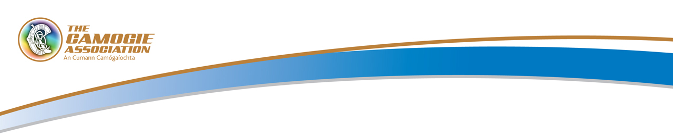
CC2 Team List

Comórtas |  | Foirne |  | -v-
(Competition) |  | (Teams)

Club |  | Contae

*No. | Gaeilge | Béarla

Ionadaithe / Substitutes Numbered 16-25

Camogie Association, Croke Park, St Joseph's Avenue, Dublin 3. Tel: 01 865 8651. www.camogie.ie

Foireann Bainistí
Role/ Ról | Ainm as Gaelige | Béarla
Síniú an Oifigigh ____________________________________ Dáta ________________________
(Official’s Signature)

Síniú an Réiteora ___________________________________
(Referee’s Signature)

Tabharfar dhá chóip den bhfoirm seo don réiteoir, a thabharfaidh cóip amháin de, do chaptaen na foirne eile.
(Two copies of the completed form shall be given to the referee, who shall give one copy to the captain of the opposing team).
Camogie Association, Croke Park, St Joseph's Avenue, Dublin 3. Tel: 01 865 8651. www.camogie.ie

